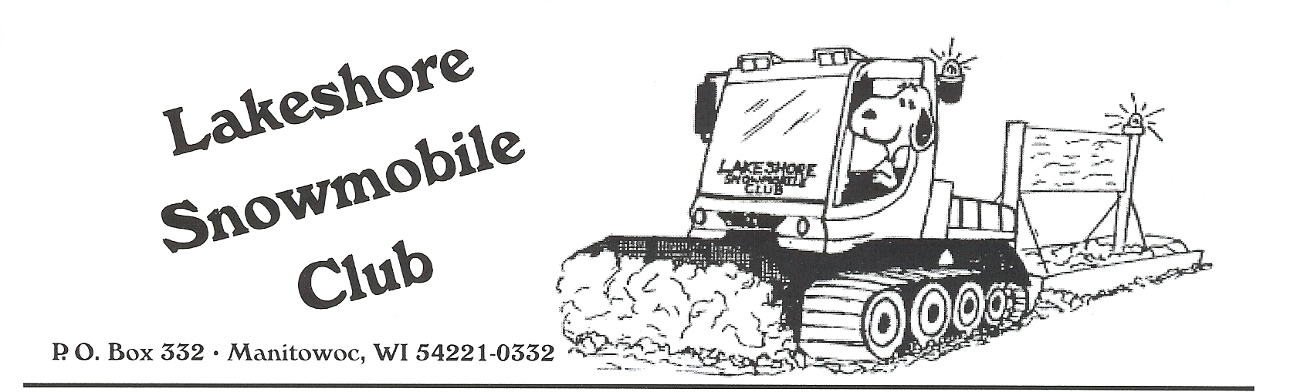
Reimbursement Form

The Lakeshore Snowmobile Club may reimburse the following expense request:

__________________________________________________________________
(include receipt with amount circled)
to the following club member:

MEMBER NAME: __________________________________________________

Address: ___________________________________________________________

___________________________________________________________

Phone #: ___________________________________________________________

E-Mail Address: ____________________________________________________

If this request is for a Snowmobile Safety Course Registration,
include proof of successful completion of course, and indicate:

Child’s Name: ______________________________ Age: _________________

Child’s Name: ______________________________ Age: _________________

For Club Purpose:
Amount Paid: __________

Check #: __________

Club/Member Copy Date Paid: ____________

